Computing Exp 6

Task: Create a model that helps represent n dimensions(n>2) into 2 dimensions only

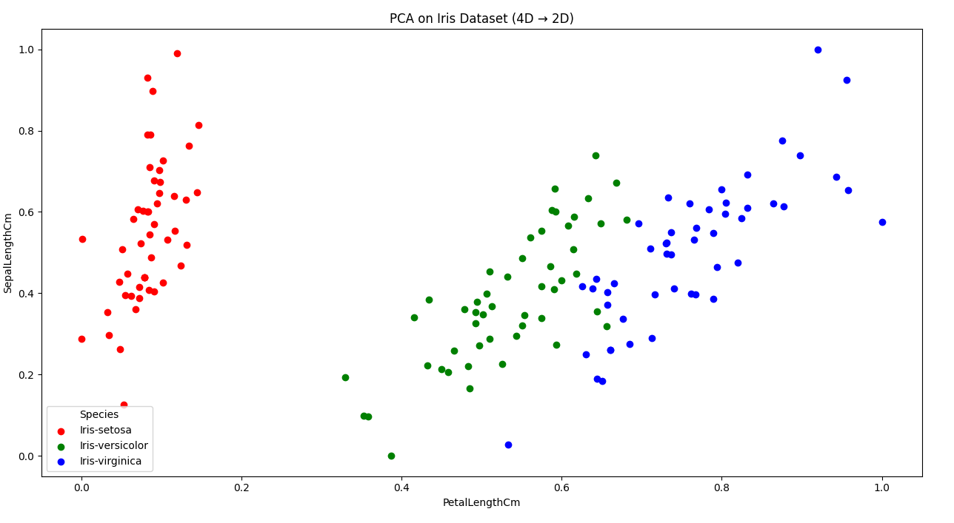
4 Dimensions to 2 dimension (Iris dataset classifying flowers)
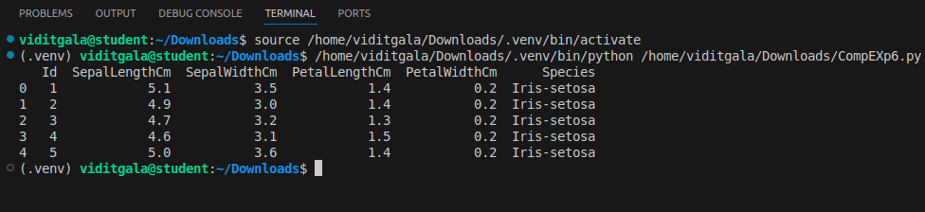

7 Dimensions to 2 dimensions (Orange quality dataset rankings range from 5 to 2.5)
